# What is REST API? | Web Service

* REST: Representational State Transfer
* REST API is used to send the state of an object (i.e., data) from server (in my case Windchill) to client (in my case Thingworx).
* Data will be sent from server to client in XML or JSON format.

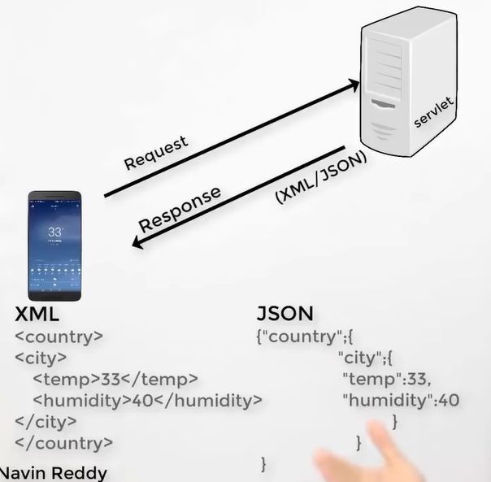

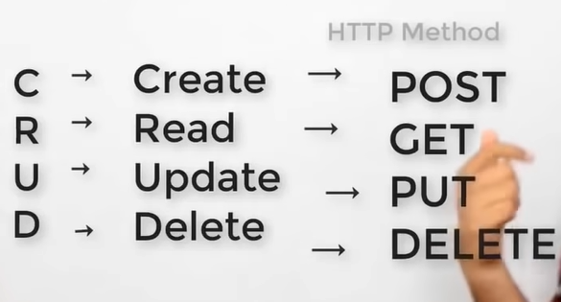

**Type of Requests:**

* GET
* POST
* PUT
* PATCH
* DELETE
* COPY
* HEAD
* OPTIONS
* LINK
* UNLINK
* PURGE
* LOCK
* UNLOCK
* PROPFIND
* VIEW

# Restful Web Services Introduction

* No Theory part to take notes

# Creating a Jersey Project in Eclipse

* No Theory part to take notes as it is just eclipse configuration

# Running the first REST Jersey Application

1. Let us a create a sample JSP file as shown below.

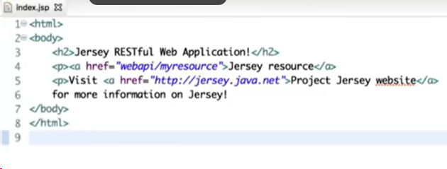

1. Create a Resource java file as shown below (Do not bother about the content as it will be explained in the next chapters clearly).

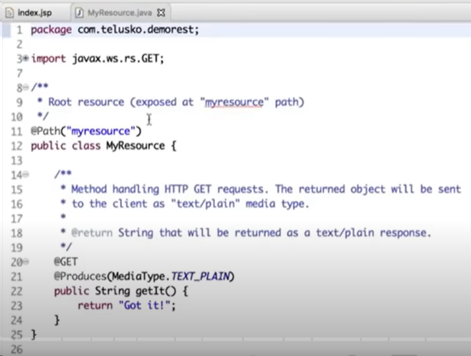

1. Now when you run the application we should get “Got it!” as result and the result may be at console or may be in the page.
2. Now if you try to access the result page it will display as shown below.

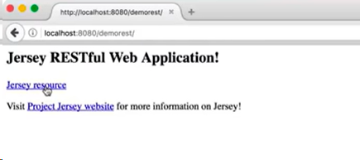

1. Now if we call myresource by updating the URL as shown below then we will get the error.

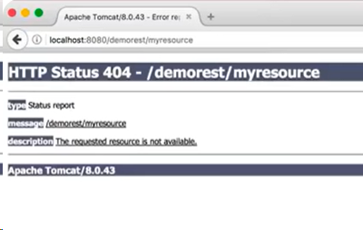

1. Reason behind the error is it is not able to find the resource.
2. If you open **web.xml** file then you will observe the entries for Jersey application where it is having the class that we need to use to handle the Jersey request “**ServletContainer**” and it will accept the URL which is having the format of “**/webapi/*”**
3. Now if you reformat the URL as shown below then it will work.

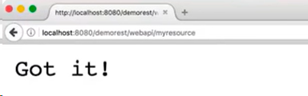

1. To get the results from the web page just click on “Jersey resource” hyperlink which will give you the results.

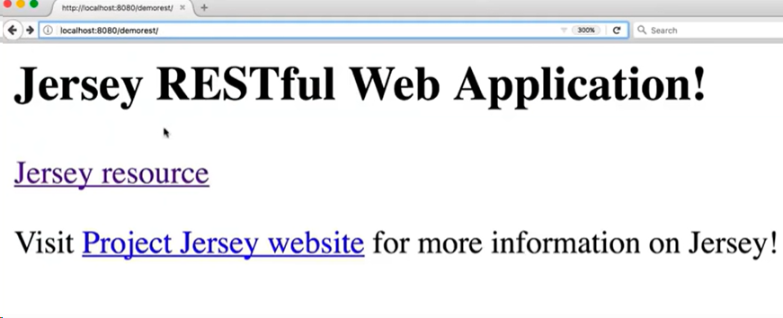

1. Result it as shown below.

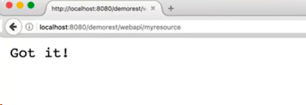

**Note**: If we remove the /**webapi**/ in the web.xml then we need not to reformat the URL.

**Note**: By default, all the requests are **GET** request if we do not mention anything.

# How to create a Resource Class

1. In this tutorial we are going to create our own resource.
2. First create a class as shown below.

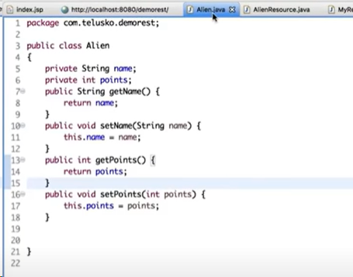

**Note:** To generate the getters/Setters just **right click on eclipse 🡪 Source 🡪 Generate Getters and Setters..**

1. Now create a resource for the above Alien class as shown below.
   * **@Path** : Used to trigger the class based on the URL.
   * **@GET** : To call the method.

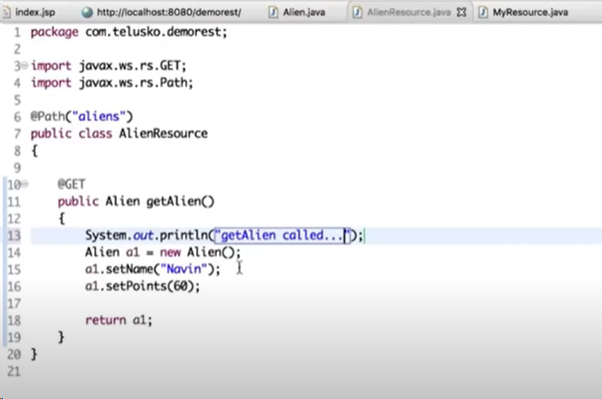

1. Now if you restart and run the application then the result will be as shown below.

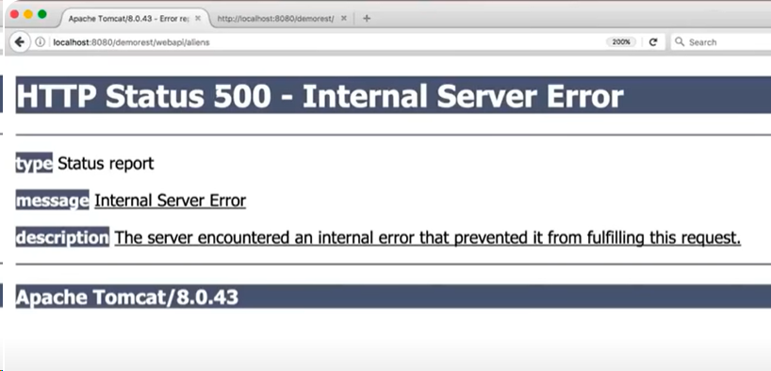

1. But in the console, it is printing the SOP statement and it is saying **MessageBodyWriter** not found.

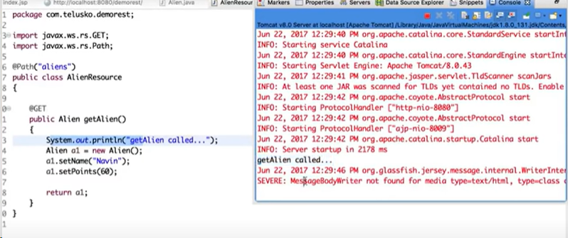

1. Reason behind the error was whenever you are returning something you have to specify what type of data you are returning.

* **@Produces** is used to return/produces in specific format (In the below example it will return/produces in xml format).

1. Again, after restarting and running the application it is still giving the error.
2. Now to return the output in the xml format we need to add one element in our Alien class.

* **@XmlRootElement**

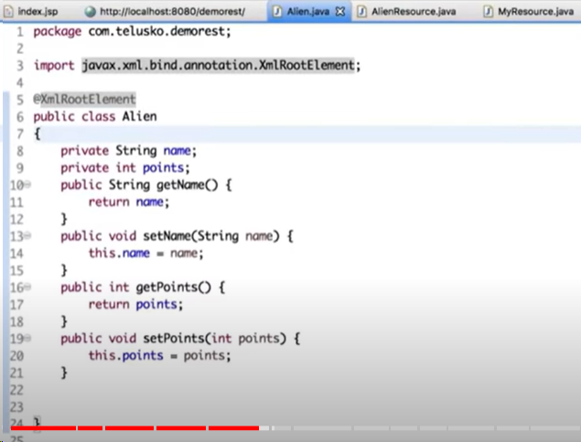

1. Now if you restart and run the application the result is as shown below.

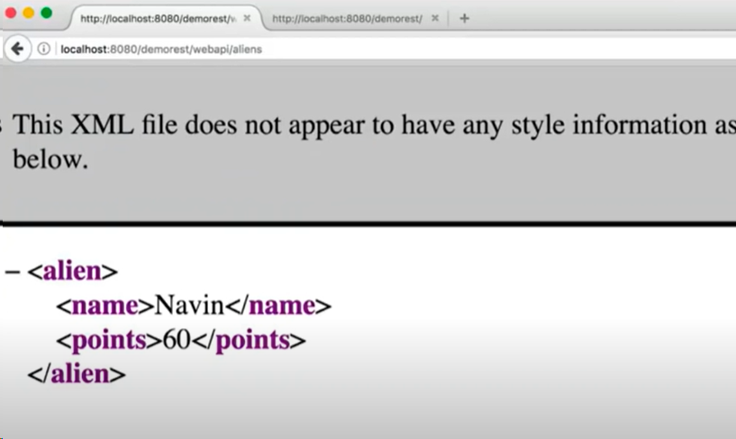

# List as Resource

1. If we need to return a list of aliens, then we need to do the following in the resource java file.

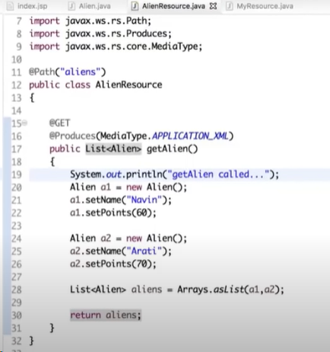

1. Restart the Apache.
2. Now it will give the results as shown below.

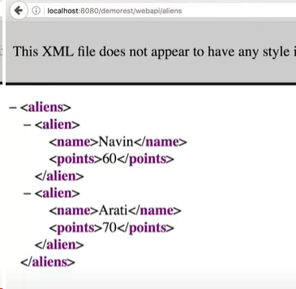

# Mock Repository

1. For dealing with specific alien information create a separate class as shown below.

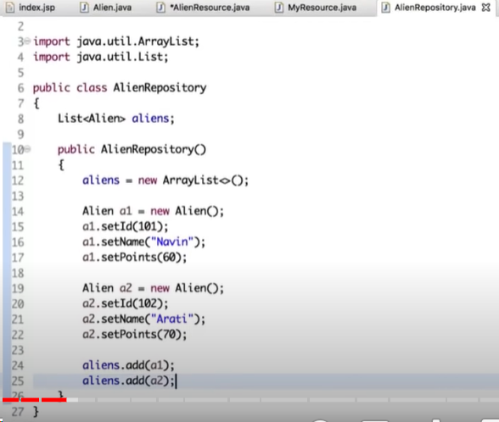

1. Now we need a method in the same class which will return all the alien information.

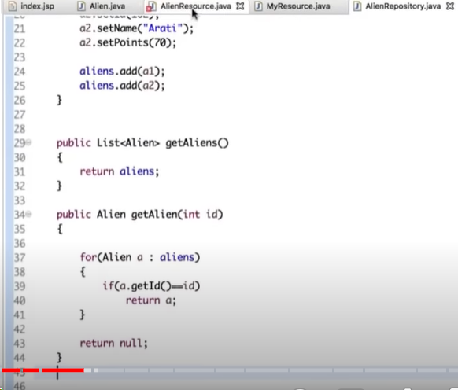

1. Call the required class as shown below in another class.

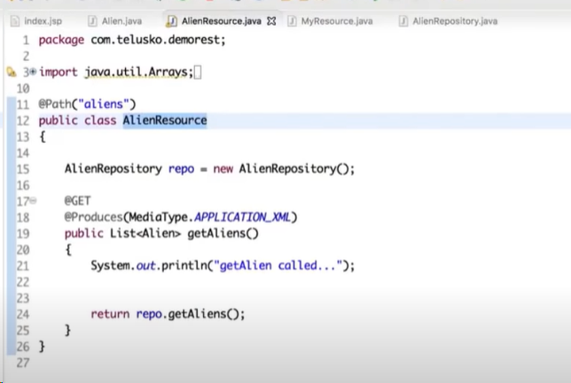

1. Restart Apache.
2. Below is the output.

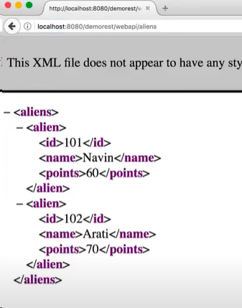

# Creating a Resource

GET: To fetch the data

POST: To create the data

PUT: To update the data

DELETE: To delete the resource

1. Below logics are equivalent to create a data in database.
2. Now update the class as shown below.

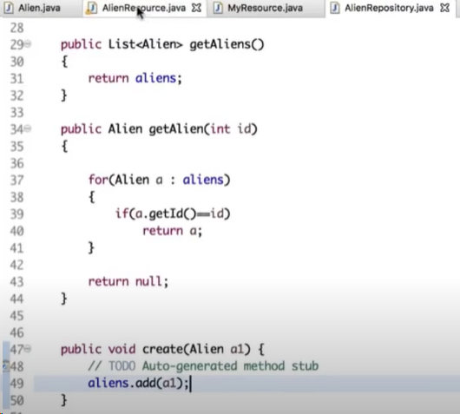

1. Update another class file as shown below.

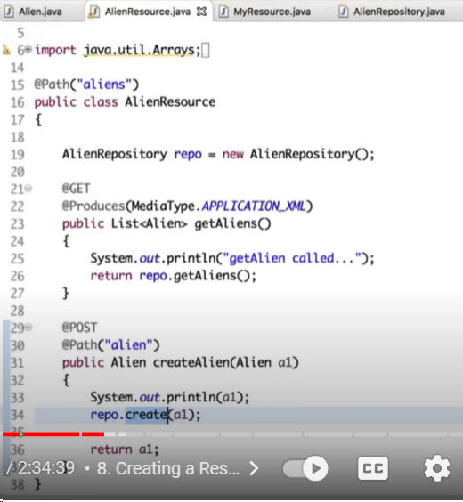

1. But the question here is how we send the data as we are not using any Form kind of things to submit the data. We need to use a tool to do this and in this case we need to use **Postman**.

# How to install Postman

Install Postman as a part of this section

# Send a Post Request

1. If we want to send a Postman request again we have to use XML because we have an alien where we have written XMLRootElement as shown below that means we are expecting an xml resource.

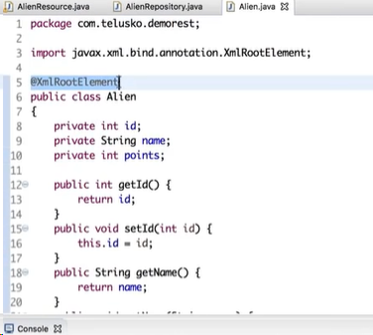

1. Now open Postman and update the information as shown below.

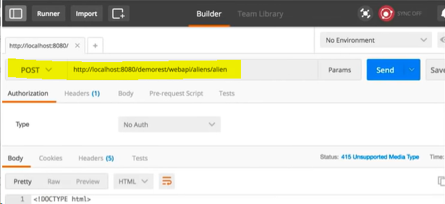

1. Also, in the **Headers** section we need to mention whatever data we are sending.

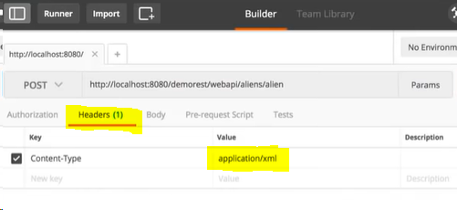

1. To send the data to the server we need to update the **Body** section with required data.

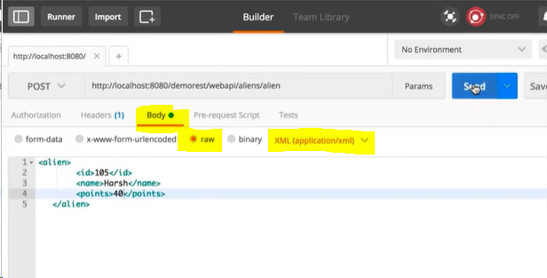

1. Also, update Alien.java file with toString method.

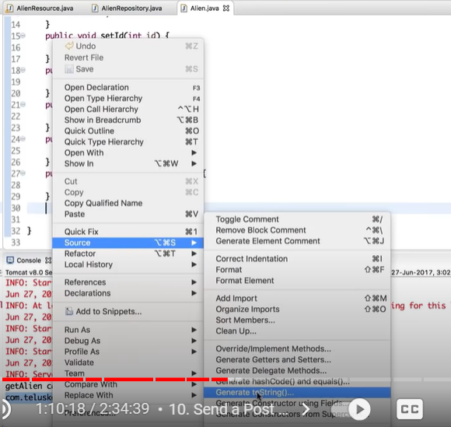

1. Let’s go to Postman and click on Send request and the data is coming on to the server as shown below.

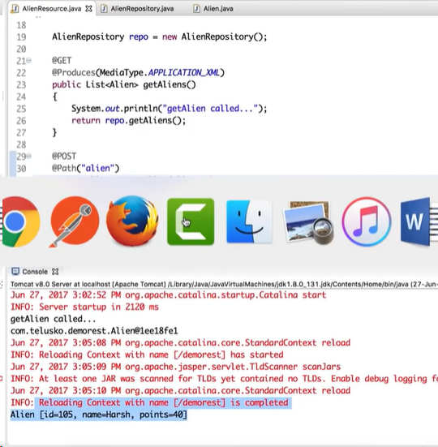

# Path Param

1. To return the specific alien information based on the ID do the following.
2. Create a new method in AleinResource.java file as shown below.

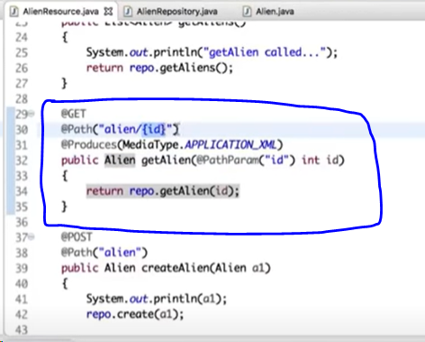

1. Restart the server and send a request from Postman and the results are as shown below.

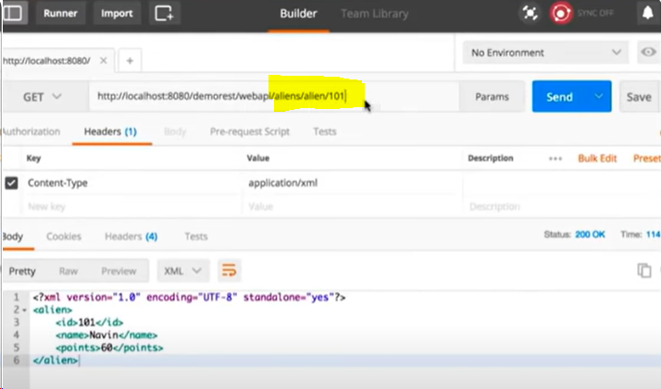

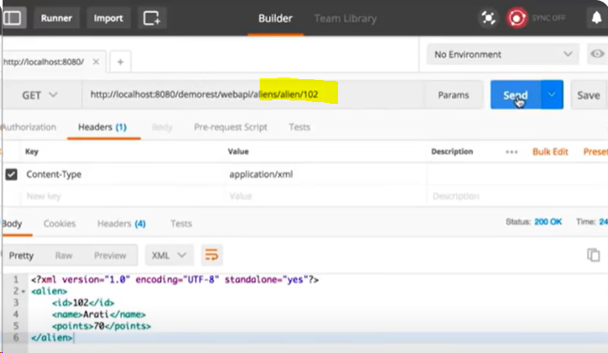

If we request for a value which is not present in the data then it will simply return zero. In this I’m looking for id 105 and the results are as shown below.

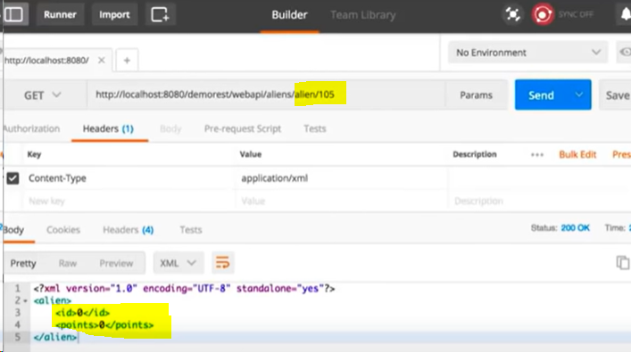

# Working with JSON

1. Till now we are getting the results in xml format but what if we need to get the JSON format and in XML format based on client interest. Below points help us to achieve that.
2. Just update the Media Type with JSON as shown below.

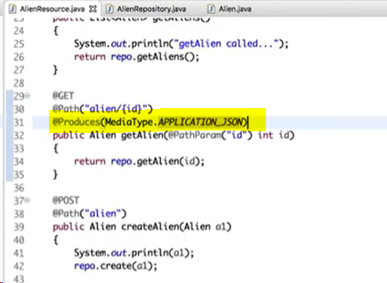

Note: Jersey requires additional dependencies to give the result set in JSON format as XML is the default format in jersey. To do that we need to add or uncomment the JSON dependency related property in pom.xml file as shown below.

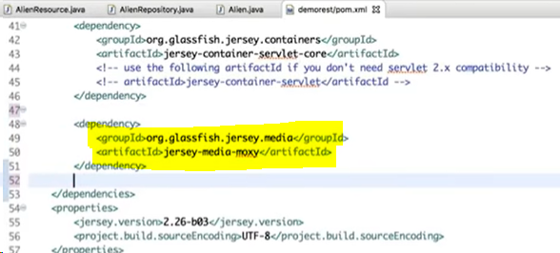

1. If we send a request to get the results as JSON as shown below then we will get the result set as JSON.

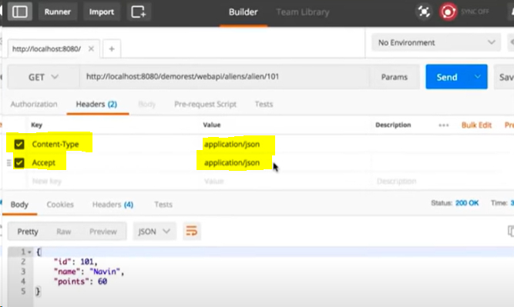

1. Now if I send the request for XML as shown below then it will throw an error.

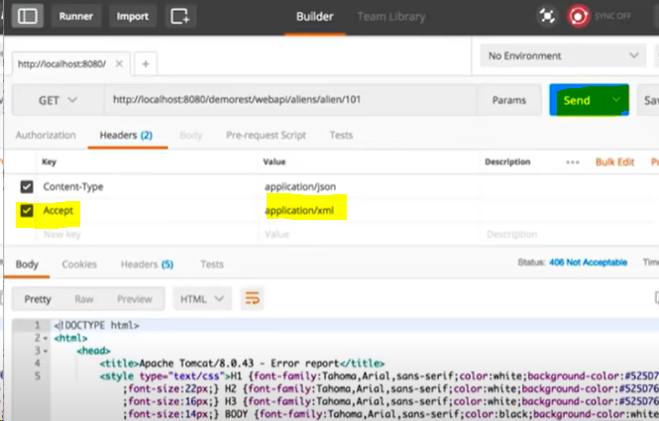

1. Now if we update the **@Produces** param as shown below then it will give us both the JSON and XML result sets.

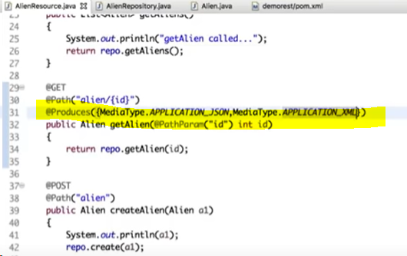

1. Now I’m sending both the XML request & JSON requests and it will work as shown below.

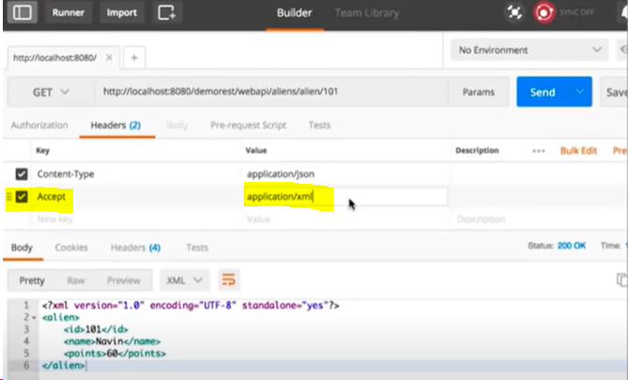

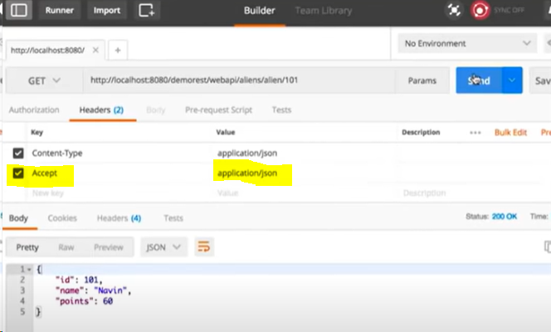

1. Also, if we need to get all the Alien details as well in both the JSON & XML format just update the @Produces param in the respective method as shown below.

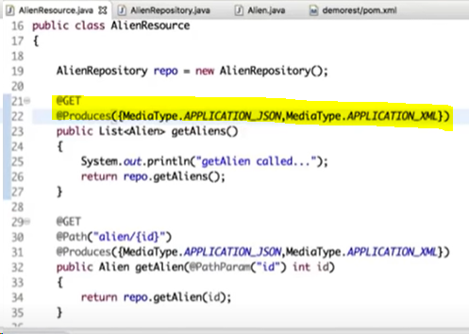

1. If we send the request for JSON result set then the results are as shown below.

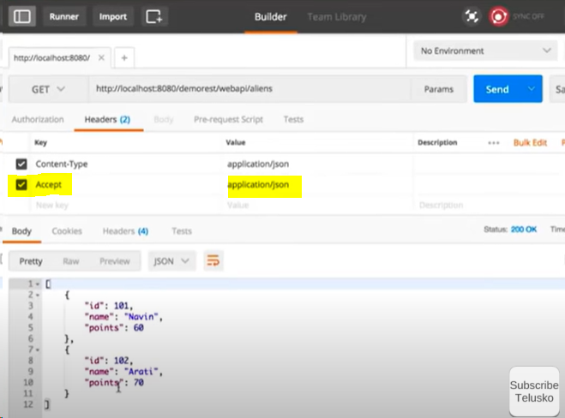

1. If we specify XML then the results are as shown below.

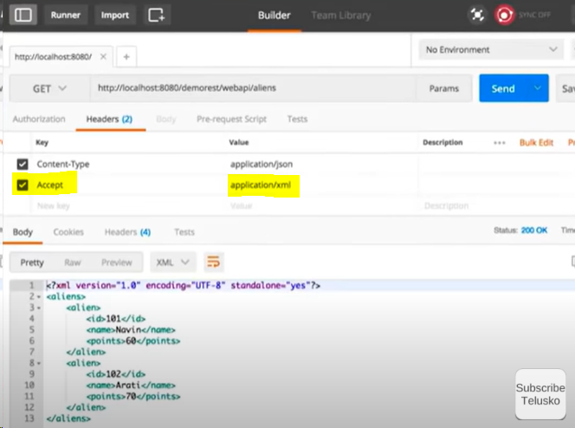

# MySQL Repository Part -1

1. In this section we are going to store and get the details from the Database and not from the fake repository (i.e, Using the java class file we are getting the details as of now).
2. Now import a java package and create a connector as shown below.

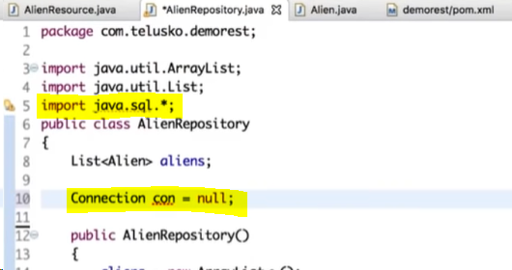

1. Remove all the static things like List and the static code in the method.
2. For use DB first create a dummy DB, if the DB already there then simply use that dummy DB.
3. Create a blank table in the dummy DB as shown below.

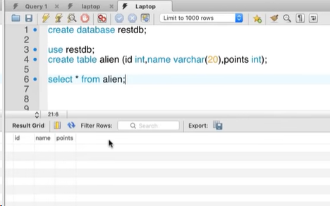

1. Establish a DB connection with the help of java as shown below.

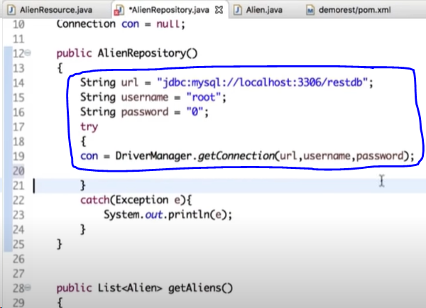

1. Load the driver as shown below.

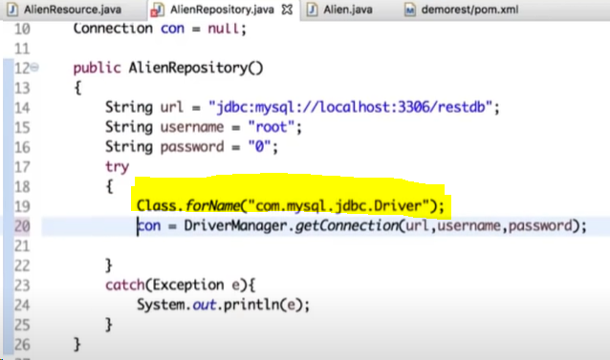

1. To update the data in the database we need to do that with the help of query and we are going to do that in our next section.

# MySQL Repository Part – 2

1. To get the alien information from DB update the code as shown below.

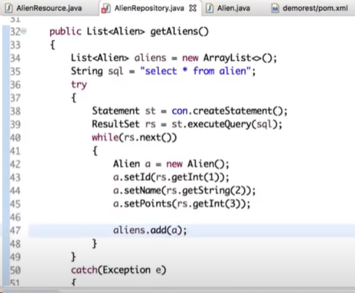

1. If we need to get the individual alien details based on the id then we need to develop the logic as shown below.

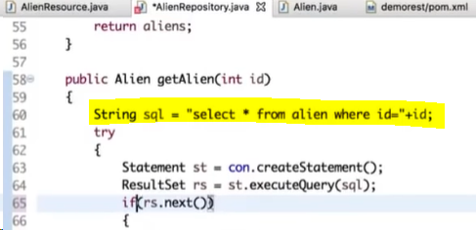

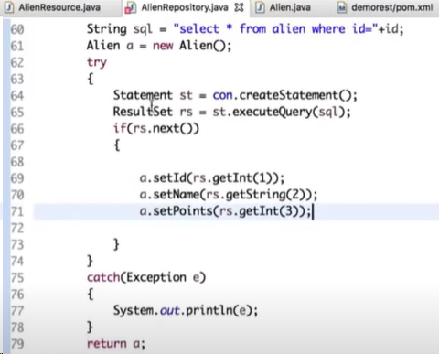

1. Now to create the data in the database develop the logic as shown below.

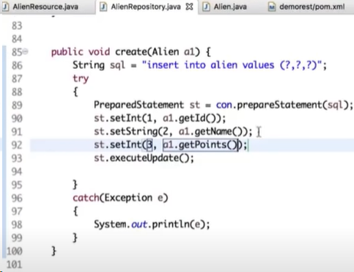

1. Restart the server.
2. Open postman and try to fetch all the alien details as a first step.
3. It is giving the empty data set as we did not create any aliens yet in the database.

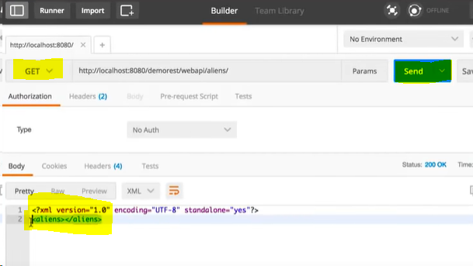

1. Now to create the data send a Post request as shown below.

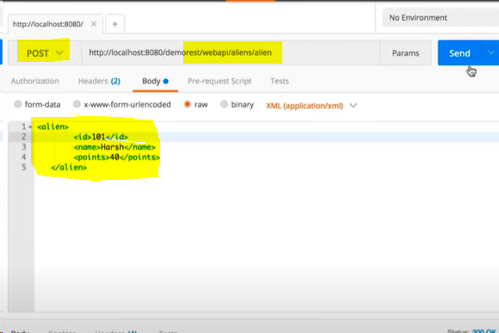

1. Now to see if the data was inserted in DB just execute a query in the DB & verify the results as shown below.

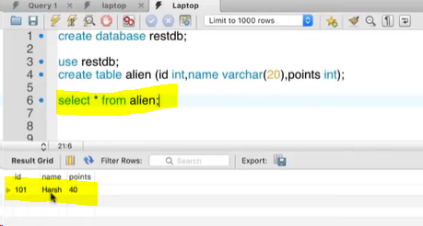

1. Now send a GET request and verify if we are getting the alien details as shown below.

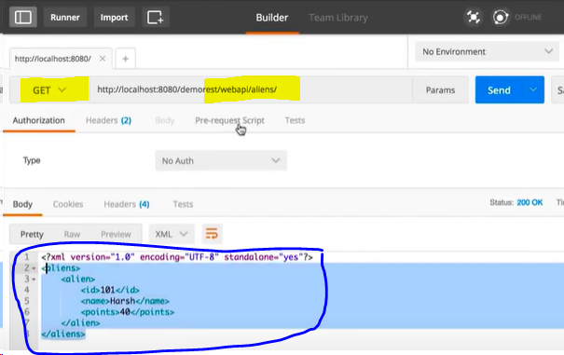

# Consumes JSON and XML

1. If you need to send the data to the server to create a new alien & trying to send the data in format as shown below.

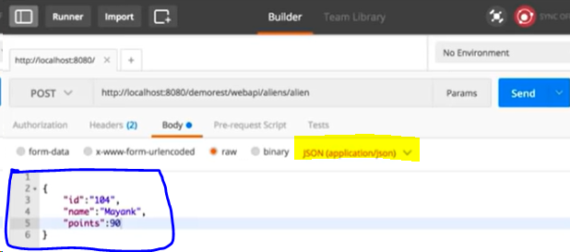

1. If you want to specify what type of data we need to accept then we can use **@Consume** to achieve this as shown below. In this use we need to accept only XML data so we need to add @Consume as shown below.

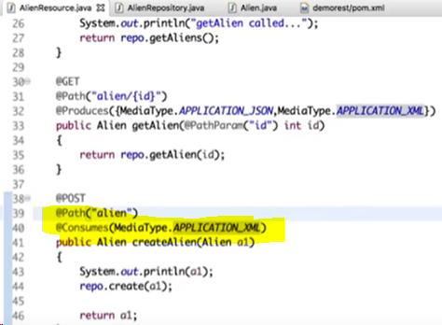

1. Now if you try to send the data in JSON format then it will fail because we are acception on XML data.

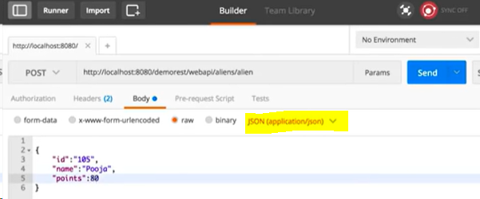

1. We are getting an error saying “**Unsupported Media Type**”.

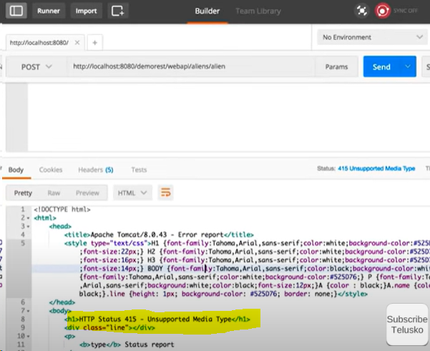

1. Now if we send the data in XML format, it will work.

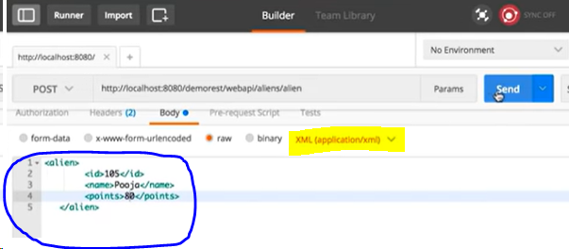

1. If we want to accept both the XML and JSON, then we can achieve that by using @Consume parameters as shown below.

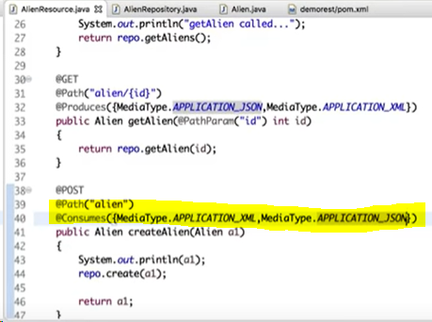

# Update Resource using PUT method

1. To update the data just create a java method in the resource java file.

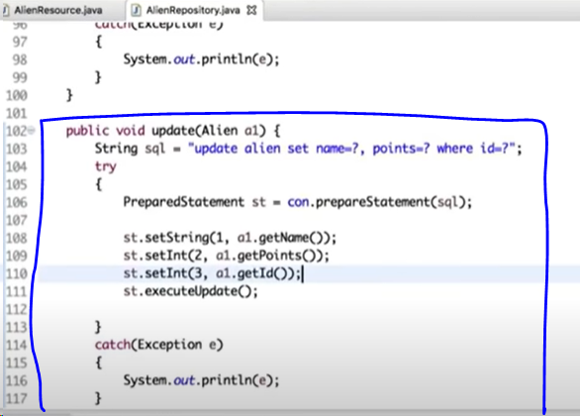

**Note:** POST and PUT can be used vice versa i.e, PUT to create & POST to update but the issue here is when some one looks at your code then they will not understand what you’re doing as you’re not following standards.

1. Now update the code as shown below to accept PUT request to update the data.

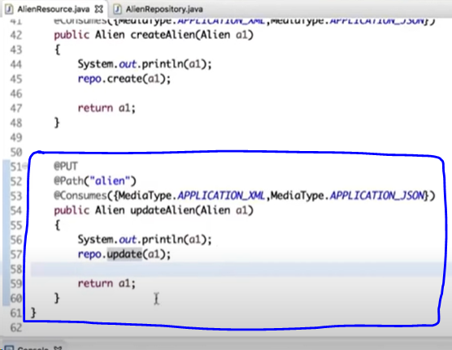

1. Before updating below is the data in DB.

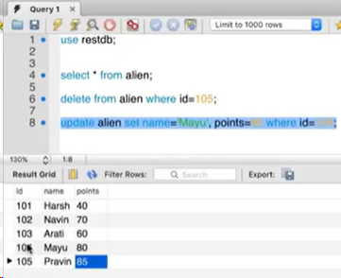

1. Now I’m sending a request to update Mayu to Mayank and point from 85 to 90 as shown below.

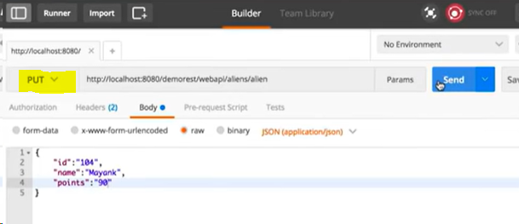

1. If you observe the database then the values are getting updated successfully.

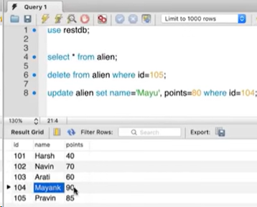

1. If you try to update the data that was not there in the database as shown below then it will not work.

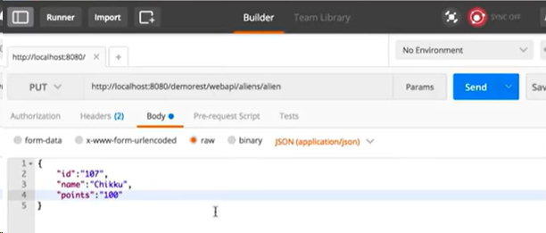

1. If we need to create the data in case the data was not there and update the data in case the data was already there, then we need to do the following update.

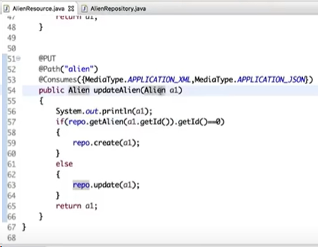

1. Now if I do the below then it will create the data successfully.



1. The data is getting created as it was not already present.

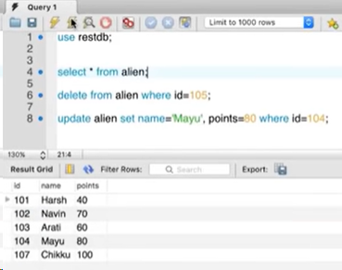

# Delete Resource

1. Create a method in the repository as shown below.

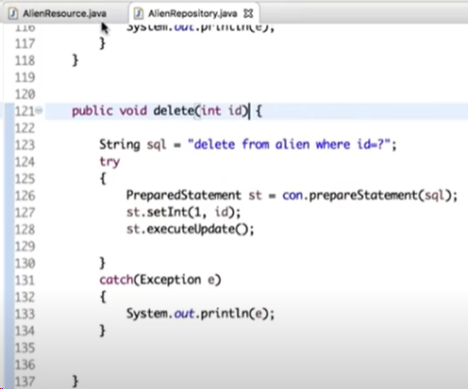

1. Also create a method in the resource as shown below.

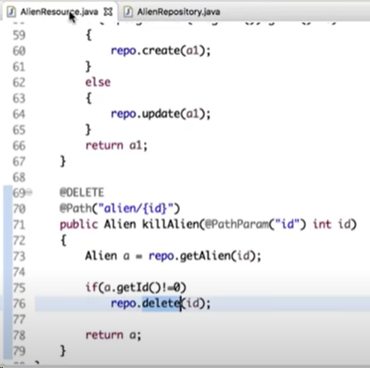

1. Now I’m sending the request to delete 101 as shown below.

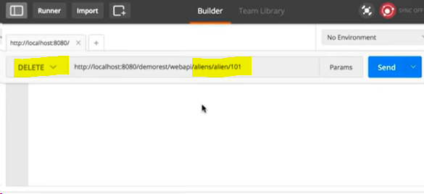

1. If you verify in database it is deleting the data.

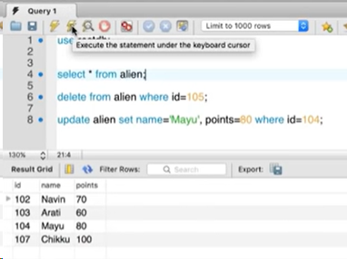

1. If we try to delete the data that was not there then it will not do anything as we a code in such manner.

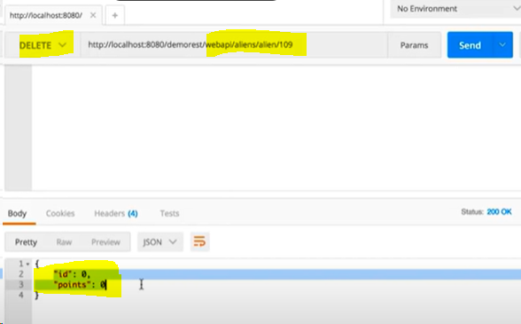

# Restful Web Services Recap

* No Theory to take notes as it is just a recap.

# Spring Rest | Spring Boot Example

1. Below are the examples to use REST using Spring.
2. Create a resource as shown below (reuse same Aline.java file that we used earlier). **@RestController** is a spring keyword which indicates the below code is related to Spring boot. **@RequestMapping** is equal to @Path in jersey.

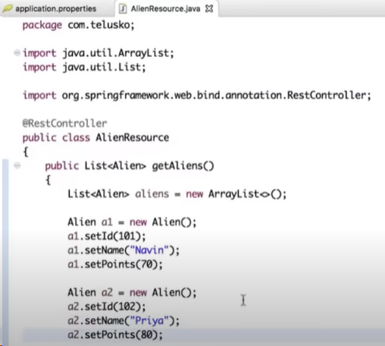

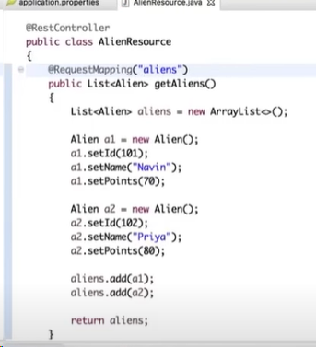

1. Restart the application.
2. Results are getting as expected when we send a request.

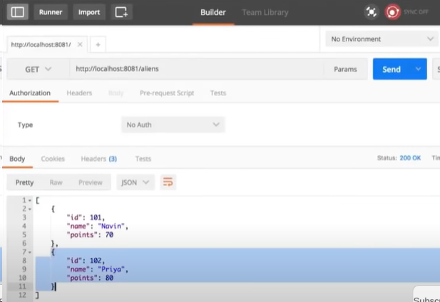

1. We need not to bother about other type of dependencies like Media type and so on.

# Spring JPA Rest

1. If we observe in the earlier session we didn’t used **@GET** and remaining requests in the code but if we need any specific kind of requests, then we can update @RequestMapping as below for the respective requests.

* **@GETMapping**
* **@POSTMapping**
* **@PUTMapping**
* **@DELETEMapping**

